A Barbet is a Barbet is a Barbet

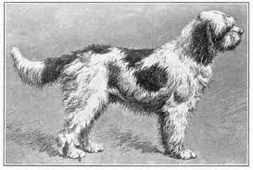

FCI/SCC standard: 105 (21.02.2006)

- The Barbet is qualified by the Société Central Canine as a rare French breed due to the fact that there are less than 50 births per year in France. It has never been a widespread breed. However there are many Barbet -type dogs in France.
- It is a major contributor to the French canine patrimony due to the amount of breeds that contain Barbet blood in their veins.
- The Barbet is known as the specialist in retrieving fowl in thick reed and swimming in extreme temperatures. It is the canis aviarius aquaticus par excellence. It has natural retrieving instinct.
- The Barbet was named in France for the first time by Jacques du Fouilloux in the 16th century.
- It is qualified as a very “undistinguished” and rustic dog.

The Barbet is THE French Water Dog and part of the bigger family of water dogs, of the SCC ( Société Central Canine) 8th group, which includes the Spanish, Portuguese, Dutch water dogs and several water Spaniels. However, it is not a Spaniel. France is the only country where the water dog has an official name: “BARBET’. The water dogs that exist in other countries do not bear that particular name for their breed. The 8th group does not include the Hungarian water dog, or Puli, considered a shepherd.
A second name for the Barbet was: Griffon d’arrêt à Poil Laineux (wooly-haired pointer) or Griffon Boulet, now extinct, which ressembled the Barbet. It only existed in brown.

History:
The Barbet has a very long history which dates back to at least the 16^{th century}. Before that time, there were water dogs/ rough water dogs in many countries, but they were not called Barbets.
The word” Barbet”, historically and in France, was a generic word used to designate any long haired dog with a beard (barbe) before it became the official name of a breed of French dogs.
How did the Barbet get to France and become a French dog? Hard to say and theories abound. When Attila the Hun moved across Europe he certainly had sheep and herding dogs to manage them. There are maps showing how they moved across countries, settled, mixed with local dogs and hundreds of years later when standards were written, each country had their own to write about.
If the Barbet came up through Africa with the Moors in the 8th century, that could have been part of the migration from Mongolia.This having taken centuries!

Dogs have been around as long as humans have to help them hunt. They also protected livestock, their home and their master. The oldest dog breeds are not the poodle type, but the Dogue, the Spaniel, or Basset type dogs (primitive dogs).

Henri IV’s mistress refers to a Barbet she took to mass with her along with her monkey and her buffoon. The Grognards of Napoleon had a Barbet as mascot. His name was Mustache.
There are many references to the Barbet in French literature (from Jules Verne, to Lafontaine and Voltaire.
Painters such as Oudry, Huet and Monet painted the Barbet.
Mahler also made a very famous watercolor of a couple of Barbets in 1907.
and many cynophile authors of the 19 ^{th and 20th} centuries refer to the Barbet as an exceptional swimmer, but not a great pointer (although how a dog points and the definition of pointing also differs from country to country). That could be a reason for the move into the 8th group in 1986 when Jean Claude Hermans decided to take care of it. Regardless, it remains a griffon type dog.

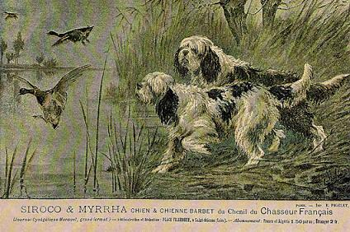

All along the Barbet was mixed with other breeds. It has contributed to the making of many breeds such as the Briard, the Berger de Beauce (Beauceron) the Terreneuve, the diminutive poodle and the standard poodle. It is also famous for being one of the 7 founding fathers of the Griffon Korthals.
The Poodle (the Germans call it Pudel from the word puddle) was, in the meantime, becoming the chien-cane (canard = duck) and eventually Caniche and onwards from1860, it was quite easy to make the difference between a Poodle and a Barbet.
In 1861 in France the poodle accompanies the 'bourgeois sportsman ‘describes the poodle at that time as 15 to 18 inches tall (38 to 46 cms), very thick coat, and falling in long, sharply twisted curls or ringlets, while the colour is either pure white or pure black, but that usually they were a mixture of the two colours.( also called parti-poodles, or harlequin).
The Poodle in France was selected for solid only colors whereas the Barbet took on shepherd colors, and different colors from the different breeds it contributed to. As an example, the brindle color could come from Portuguese Water Dog roots.

The Poodle was and is a finer, elegant, taller dog, the tail was cut and it only came in solid colors. It was accepted into ladies’ salons and it was perfumed!
The Barbet stayed in the countryside and the expression “crotté comme un Barbet” (to be up to the ears in dirt) continued its path, hunting, swimming and mixing with other breeds.

Some of the “old Barbet” colors have come out in the last 5 years in the Authentic or Vieux Barbet Français. For many years, those colors had not been seen along with the pied colors.

It is interesting to note that the same differences remain today between the Standard Poodle and the Authentic Barbet or Vieux Barbet Français as existed in the past.

The Barbet characterized by the Count de Buffon (1766)below, no longer exists.

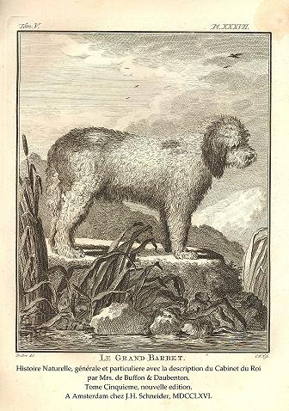

Is there just 1 Barbet as some claim today? It would be difficult to admit, considering the evidence available along with the standard written in France for a gundog/pointing dog called the Barbet d’Arrêt . (SCC 7th group classification).

There are more likely 2: a Barbet Moderne and the Authentic Barbet or Vieux Barbet Français.

However, there is only one standard. It was written in 1891 for a Griffon Barbet d’Arrêt.
The Barbet Moderne school of thought believe in the re-incarnation, as explained by its
“father”, Jean Claude Hermans who thought that by selecting, crossing and re-crossing poodles he would eventually get back to the Grand Barbet de Buffon (circa 1766). Jean Claude Hermans’s Barbet was to be as tall as possible and the tallest of the waterdogs.

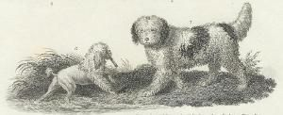
Abraham Reese quadrupeds 1820 ( petit et grand Barbet)

The Grand Barbet, measuring about 55 cms at the withers, was selected in the mid 1800’s, to evolve into a sophisticated standard poodle. What was not “selected” continued as a rustic dog which is the one many mention in the 19th centrury as being an unsophisticated farm dog.
The Petit, the size of a diminutive poodle, a bichon, or a little lion dog already existed as depicted in many paintings by Oudry and several French painters in the 18th century. They mostly are shown with a lion cut which was popular in the 15th century and onwards.
The French paintings shown with dogs in hunting scenes were dated before the French Revolution, because the Barbet (mostly the Petit) was used by kings such as Louis XV for hunting. After, the revolution, many years went by before selection started again, for obvious reasons.
In the 19th century, most of the paintings were by British artists such as Stubbs, Donovan, Gainsborough, Reinagle, Emms.

The Barbet was a valuable hunting companion used for retrieving wild fowl shotdown, from water and on land. They are said to have a very soft mouth.
Their thick, long, curly coat provides resistance to extreme temperatures. It also proved to be a handicap sometimes when catching everything like Velcro! It required a tremendous amount of care.

At the beginning of the 20th century, it began its decline because there were English hunting breeds being imported into France and they were more all-around breeds, and they had a short coat. The Barbet declined, but was still found in the countryside with many stories of people being narrated, who had Barbets in their childhood, in many areas of France, close to the Belgian border, the Somme area and later in the 1920’s and 30’s closer to the south of France. In other words, anywhere there was marshland, water and waterfowl to hunt.

There were a few breeders before WWI, one of which was a M. Coste who produced a Barbet by the name of Pilote who portrays the Griffon-Barbet standard. He is a typical representation of the Authentic Barbet or “Vieux Barbet Français”.

There were Barbets who hunted in the south of France, near the Camargue region. Two breeders were working together. They were the Floirac (Hourie de Floirac was the 1st Barbet to be LOF registered) and Mas de la Chapelle kennels ( Joyeuse du Mas de la Chapelle).This is in the 30’s and early 40’s. WWII came along and put an end to a lot of breeding, not only Barbets, but other breeds in many countries hit by war. Many breeds and not just the Barbet suffered from lack of precise ancestry. Many recovered due to close cooperation of a few people who worked for the survival of the breed..
There was not money around for futile expenditures. Not many were interested in “wasting” money registering dogs( there was no logical reason to, at the time).
Dogs worked,hunted, reproduced healthywho corresponded to the specifications they had ( standard!) dogs and everyone was happy. The Barbet was not an exception.

In the same village called Graveson as the village where Doctor Vincenti, of the Mas de la Chapelle kennel, lived 2 brothers who saved the Barbet from extinction. The Ayme brothers, neighbours to the Mas de la Chapelle,in the Mas de la Musique, were able to keep the breed alive. In the 50’s, during a trip to Portugal, they saw a dog that looked like a barbet-type dog, a Portuguese Water Dog and brought him back with some cattle in a truck, to bring some new blood to the Barbets they had.
The original strain was therefore kept alive up to the 60’s, none having been registered at the SCC for many years. A Miss Postigo registered some Barbets at the SCC in the late 60’s. These were ATI because the SCC had no records of the ancestry which had been kept alive in Graveson, by the Ayme brothers.
In the early 70’s Miss Postigo offered Mrs Pêtre (Doctor Vincenti’s daughter) a Barbet and breeding started again. This is the same process that was used by many breeds around the world and not just in France!

Mrs Pêtre registered a kennel name in the early 80’s. It was Barbochos Reiau de Prouvenco. The dogs were SCC registered as Barbet d’Arrêt.

In 1977, Jean Claude Hermans, who had been a groomer and was very interested in the canine world, wrote an article about the corded Poodle in a canine review.
He then took an interest in a rare breed called the Barbet. He had seen an ad in a canine revue, about Barbet puppies available in the south of France. He thought the breed extinct for over a hundred years and was intrigued. He contacted the breeder, Mrs Pêtre but never went to see her. After having seen 1 dog that had been placed in the Paris area where he lived, he had as a plan to start from scratch, ignore any of the SCC/ LOF(Liste des Origines Françaises) registered Barbets and decided to re-incarnate the breed.
He went around local rescue centers around Paris and selected some ATI (
A Titre Initial = no known ancestry) registered them and called them Barbets. Then, he began mating them without any known breeding plan. At some point, he was given the right by the SCC to do a cross-breeding( of a Barbet with a Poodle) to add some diversity. Since he had decided to re-incarnate the breed and prtended the Barbet was extinct at the turn of a century, he began using poodles and crossing them (brothers and sisters/ daughter and father).
The first true crossbreeding of an Authentic Barbet with a Poodle only took place in 2000.
He had a difficult time finding poodle breeders who would accept to work with him because at the time the Poodle club of France was against his “plan”.

In 1980, he decided to start a club, proclaimed himself president andalso become an SCC judge. He needed to have at least 50 births per year to be able to stand on his own. He climbed up the canine ladder and was involved in several breeds.
He did his best to get as many people as possible to have litters, only ever having one himself.
Some had LOF Barbet blood in them, some were ATI, but his strategy was to re-incarnate the Barbet de Buffon from 1760, by using Poodles, so he methodically began to refuse confirmation of many Barbets by Mrs Pêtre and her collaborators, and modified the standard so taller Poodle type dogs would correspond “better” to his vision. The Poodle coat is dominant, so it is very difficult nowadays to get away from the Poodle “type” and therefore be able to show dogs in a long coat as stated in the standard ( FCI 105).
In the early 1990’s, a German man by the name of Rainier T. Georgii and his companion Inge Fischer well know in the working dog world with her successful Irish Water Spaniel breeding, came along and used as foundation stock a Barbet by the name of Hercule di Barbochos Reiau de Prouvenco. A long collaboration started between Mrs Pêtre and the Georgii/Fischer team.

M Hermans decided to fight tooth and nail any of the dogs produced by M Georgii, who was forced to register his Barbets in Germany. Many of the pedigrees HAD to be falsified because an all-out war was raging between the 2 men. There were also many false registrations on the French side.
The situation never improved and to this day there is still a battle between the 2 factions.
Over 30 years, the breed club has never been able to resolve any issues for lack of competences and willingness to do so. Nor has it helped any breeders working for the survival of this rare French breed.
M. Georgii is honorary member of the French Barbet and other waterbreeds’ club and so is Mrs Pêtre. Their work has been invaluable for the Authentic/ “Vieux Barbet Français” ’s survival.
Many people who loved the breed and wanted to help with its survival finally gave up. That is the reason why many kennel names never registered more than one perhaps two litters before giving up. This information is available on pedigree databases.
The data about other blood added into the Barbet is available today thanks to many other breds’ pedigree databases, the archives available and the research which has been done. This has revealed a lot of valuable information needed by the breeders. These dogs all have common ancestors.
These additions, however, were necessary for the breed’s genetic diversity and survival, but known by only a few long term breeders and hidden for many years from the others.
Litters were never evaluated by the breed club and progeny registered according to breed type. All progeny was given a first class registration.
M Hermans finally gave up presidency in 2001. He is now involved in other breeds and updates a website concerning dog paintings, postcards and the likes. He is honorary member of the Swiss Barbet club.

Physical characteristics:
The Barbet is a medium-sized dog. The most visible and essential characteristics of any breed of dogs are the coat and the morphology. The coat grows down on the body and is long wooly and curly often hanging in strands
The body is slightly longer than the height at the withers. It is a stocky, vigorous, compact, unsophisticated dog. It goes to water like a duck.
The Barbet moves with a medium stride and soft easy movements define its gait with powerful hindquarters.

Muzzle is square and shorter than the skull which is round and broad. It is quite square, the bridge of the nose fairly broad, and thick, well pigmented lips covered by long hair.
Beard and mustache cover the entire nose and the coat grows down (not out like a Poodle) from the top of the skull to the bridge of the nose.

Head quality is essential. Without a correct head a dog is not representative of the breed and the Barbet’s head is very wide, but not out of proportion. The head supports the breed’s function.

Nose has wide nostrils and can be black or brown according to the color of the coat.
The Barbet has an incredible sense of smell, necessary to accomplish his work.
Jaws and teeth are strong. A scissor bite is preferred.
Eyes are generally deep brown and rounded whereas the rim of the eyelid is either black or brown. Many brown Barbets today have much lighter eyes than dark brown. This trait was brought by the mixing of other breeds. Interesting fact: Lynx, the Griffon type dog registered ATI in the late 70’s had light eyes.
Ears are long, flat and wide starting at eye level or lower and are covered by long strands of hair. The neck is short and strong and the top line is solid.
Loins are arched, short and strong with a rounded croup visible from the side as a smooth continuation of the visual line of the loin.
Chest has a rounded ribcage which is deep, broad and well developed but not like a barrel. The slightly raised tail is low set and forms a hooked end.
Skin is thick
Tail is set low and forms at crochet at the end. It does not curl over the back, but can raise to above horizontal when the dog is moving.
Colors have been of a wide palette of natural colors that range from black, black and white ( pied), dirty white and black or brown, gray, fawn, dirty white, sand and fawn.
Character:

The Barbet is a happy dog, loving, attentive and always looking to please you, admires you, is very sociable with other dogs, very playful with children. He is extremely intelligent, and needs to do some obedience at an early age. He does not appreciate people who scream a lot…as he is a peaceful dog.

Grooming:
The Barbet being a rustic dog with a long coat it therefore requires weekly brushing as the coat matts easily when not regularly taken care of.
The standard has never specified a length of coat, only “long”.
It can be shaved once a year ( at the same times as the sheep!). The hair grows more slowly on the ears and tail which is why it is not recommended to shave them entirely.

It can arbor a working cut which is much shorter but not described in the standard.
The lion cut has never been a working cut for the Barbet, but one for the diminutive and standard poodle or even the Portuguese Water Dog.
There is a propensity in several countries such as Canada and the United State, to overgroom the dogs for show purposes, but the majority do have a long coat with curly strands.
The Barbet Moderne is generally regularly shaved from head to tail.

The Barbet is gaining popularity in many countries outside of France, but its survival is not yet assured.
Long live the Barbet.

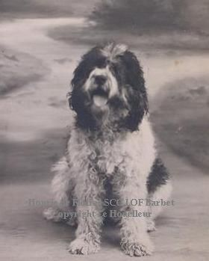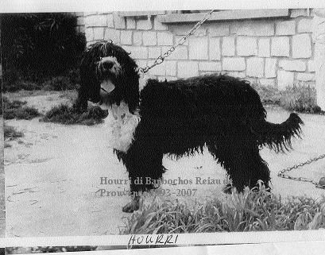

Hourie de Floirac b.1933 Hourri di Barbochos Reiau de Prouvenco b.1993

Robot translations tools can be misleading many to think the Barbet may correspond to an old French Poodle or even an H 2o dog! More and more histories are being drawn up by simply clicking on a translation tool and makes for the strangest accounts, especially to a neophyte. This document is the result of several years of first hand research from original documents, books and interviews with people who were directly concerned with the breed and have left their legacy.

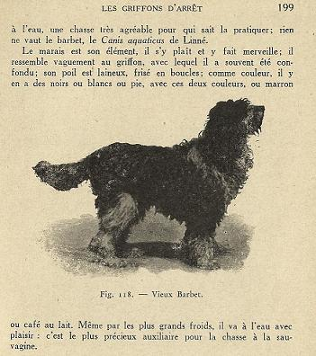

Tags: French waterdog, Vieux Barbet Français, Authentic Barbet, rustic breed, natural, curly long coat, unsophisticated.

Elaine Fichter
http://bbfrenchtreasure. Free

